Grade Kindergarten
Painting and Painting and Painting

Description: | Students will:  Learn to open the paint palette and experiment with the colors and tools.  Paint with all six brush sizes and the matching erasers.  Use the paint bucket tool.  Experiment with the Clear button.  Paint lines, shapes, colors, pictures, numbers, letters, and words.
Project View | 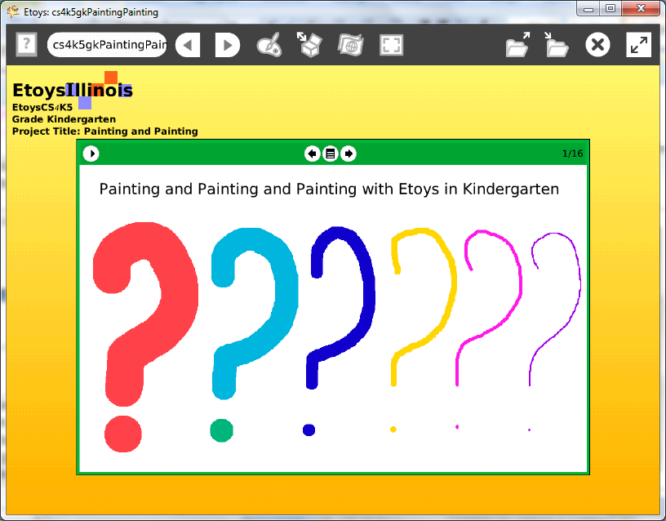
Subject: | Art, Math, Language Arts
Etoys Quick Guides | Click the question mark in Etoys to open the set of interactive tutorials for basic tools and techniques.
Vocabulary: | colors, shapes, circles, lines, rectangles, triangles, squares, numbers, letters, how many, what color, what size, biggest, smallest, top row, bottom row, right, middle, left, counting, numbers, letters
Lesson 1:  Paint Tools: Brushes  Paint Tools: Color Palette  Paint Tools: Paint Bucket | These projects introduce paint palette tools. Use the activities to support student learning in current classroom topics.  Show students how to open Etoys from the desktop and click on Make a Project.  Give students time to use the paints to play, experiment, and explore the possibilities of these tool and projects and ideas that occur to them.  The sixteen suggested activities in this project do not begin to exhaust the many ways paint tools can be used for enjoyment and for learning.  Use the activities to support student learning in current classroom topics. For example, use the paint tools to “paint four blue circles near the right side of the screen” asks students to apply knowledge about counting, colors, and location. Two students working together can give each other similar directions to develop speaking and listening skills.  Students will become familiar with Etoys and the paint tools. They need not save these early projects. Introduce keeping projects when students know the letters of their name and can find them on the keyboard.
Standards: | Common Core Standards  Mathematics: K.CC 1,2,3,5; K.G5  Language Arts: SL.K.1  Bloom’s Taxonomy/Cognitive Domain:  Knowledge: describes, knows, names, selects, states  Application: demonstrates, produces, uses  Analysis: analyzes, compares, distinguishes, selects, separates  NETS  1. a, b  2. a, b  4. a, b
Resources: | Etoys Help Quick Guides: always available in Etoys. Open Etoys and click the question mark to open a set of interactive tutorials of basic tools and techniques.  www.etoysillinois.org projects, lesson plans, software download  www.mste.Illinois.org more math, science, and technology resources  www.corestandards.org Common Core Standards  www.squeakland.org software and Etoys projects  www.nctm.org Standards and Focal Points for each grade
kh
January 2011

